**Microsoft Azure Fundamentals: Azure Containers**

**Containerized Applicaitons**

Logical app isolation boundary (the “container”)

Entire app or a single app component

**Microservices**

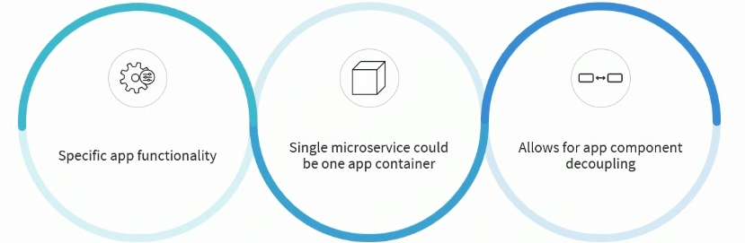

**Application Container**

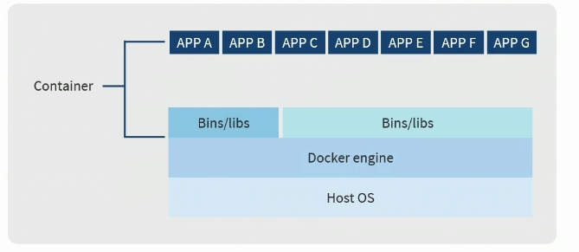

**Application Containers**

* Running containers are based on containers images
* Images contain software and settings for running a container
* Images can be created manually or pulled from private or public repositories
* A container is a runtime instance of an image

**Application Container Contents**

* Scripts, binaries, container filesystem
* App-specific libraries, components
* Runtime environment (Linux, Python, web server)
* Configuration files, software tools

**Application Container Benefits**

* App portability across containers
* Quick app startup time compared to virtual machines
* Code changes, updates, and testing done per container

**Configuring a Linux Docker Host**

Sudo apt update

Sudo apt install docker.io

Sudo docker

Sudo service docker status

Sudo docker images

Hub.docker.com (alpine)

Sudo docker pull alpine

Sudo docker images

Sudo docker run -it alpine

Ls

Exit

Ls

Pwd

Sudo docker pull caddy

Sudo docker images

Sudo docker run -p 80:80 -d caddy

Sudo docker ps

Sudo curl <http://127.0.0.0:80>

Sudo docker ps

Sudo docker stop “name”

Sudo docker ps

**Configuring a Windows Docker Host**

Docs.docker.com/desktop/install/windows-install

Server Manager 🡪 Add roles and Features Wizard 🡪 Windows Subsystem for Linux

Command Prompt: wsl --update

Docker images

Docker pull alpine

Docker run -it alpine

**Building a Docker Image from a Dockerfile**

Sudo service docker status

Sudo docker

Sudo mkdir dockerfile

Cd dockerfile

Sudo nano dockerfile

Sudo nano index.html

Ls

Sudo docker build -t webapp1 .

Sudo docker images

Sudo docker run -p 80:80 -d webapp1

Sudo curl <http://127.0.0.1:80>

**Creating an Azure Container Registry**

Create a resource 🡪 Container Registry 🡪 Create container registry

Home 🡪 Microsoft.ContainerRegistry | Overview 🡪 eastrepo1 🡪 Quick start

Sudo docker

Sudo docker login eastrepo1.azurecr.io

Sudo docker images

Sudo docker tag webapp1 eastrepo1.azurecr.io/webapp1

Sudo docker images

Sudo docker push eastrepo1.azurecr.io/webapp1

**Deploying Azure Container Instances (ACIs)**

Home 🡪 All resources 🡪 eastrepo1 | Repositories 🡪 webapp1

Hub.docker.com (caddy)

Create a resource 🡪 Container Instances 🡪 Create container instance

Home 🡪 Microsoft.ContainerInstances-20231030142029 | Overview 🡪 webapp1 🡪 Containers